**WGMY Fortnight Challenge #0203**

By : H0j3n (UiTM)

**Tools :**

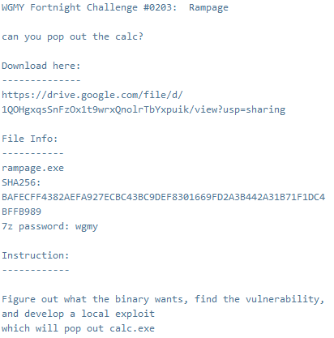

First of all I did this writeup after the challenge which I follow up the video writeup and try myself on how to complete the challenge .

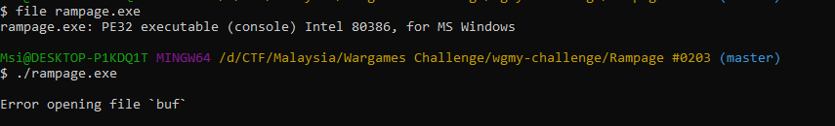

First of all we try to check this exe using file command and it is x32 and when we try to run it shows “Error opening file ‘buf’”

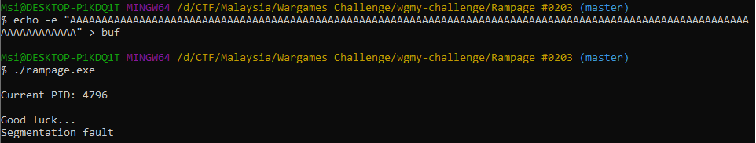

So I try to create one file name buf to check the output . From the challenge we know that it is about binary exploitation that’s why I use A to check maybe there is buffer overflow xD. It actually what we want where we get the Segmentation fault haaaa. How about we try to reduce the character A and check how much padding do it need to get the segmentation fault. Lets try and error.

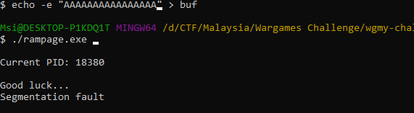

After try and error we found out that ‘A’*15 is the limit or padding then after that is what we would like to put the payload or the the things that we want to work for.

=====WILL CONTINUE=====